The Intelligent Lighting System

IT PAYS TO BE SMART

Digital Lumens offers a game-changing approach to industrial lighting with a smart, networked, energy-efficient LED solution that is proven to reduce lighting energy use by up to 90% in industrial facilities. The Digital Lumens Intelligent Lighting System delivers high-quality light when and where needed while slashing kWh use. LightRules management software provides the flexibility to match settings to each facility’s unique needs, and reports on key metrics (power use and occupancy) for easy measurement and verification.

**The Only Intelligent Lighting System**

**•Smart Lights** — LEDs, sensors, and onboard computer to manage and measure system performance

**•Networked Together** — fixtures form a wireless

mesh network to communicate with each other

**•Centrally Managed** — LightRules lighting management software provides complete control

**Most Eff icient**

• Excellent light output

• Lower wattage

• Light only when needed

**Most Flexible**

• Adaptable to facility changes and growth

• Easy to create and modify lighting settings

• Automatic and/or manual control

**Most Reliable**

• Rugged, industrial-grade LED system

• Long life reduces facility down time

• 5-year warranty

• No maintenance

**Proven & Verif iable Savings**

• Lighting energy savings of up to 90%

• Seamless M &V reporting

• Lowest annual operating costs

CERTIFICATIONS & AWARDS

• UL /cUL , UL-MX NOM, C-Tick, and CE listed

• Complies with the Buy American provision of the ARRA

• World Economic Forum Technology Pioneer 2011

• DOE/NGL Solid State Lighting Design Winner

• GoingGreen Top 50 Winner

• 2010 Plant Services 'Best Practices' Award

• 2010 Building Operations Management Top Product

LED LIGHTING FOR INDUSTRIAL HIGHBAY APPLICATIONS

• Warehouses (Ambient and Cold Storage)

• Manufacturing

• Maintenance Depots

• Hangars and Inspection Facilities

PAST PER FOR MANCE



Olean Wholesale Grocery

• (2) 15,0 0 0 f t2 freezer ; 24 x 6 operations

• 1-for-1 upgrade of HID f ix tures

• Increased delivered light from 10 fc to 40 fc

• Reduced lighting energy use by 87%

• Savings of 158 K kWh per year

• Payback 26 months

Niagara LaSalle Steel

• 20,000 ft2 High Bay Warehouse; 24 x 5 operations

• 1-for-1 upgrade of HID f ix tures

• Increased delivered light from 4 fc to 35 fc

• Reduced lighting energy use by 89%

• Savings of 134K kWh per year

• Payback 33 months

FREE LIGHTING ANALYSIS

If you would like more information on the Digital Lumens system, please contact us for a free lighting analysis. We work in concert with your electric provider to insure that

you receive all rebates that are available and the special

tax incentives created by the EPAct 2005.





5590 Camp Road Hamburg, NY 14075

(800)649-5590

www.hooperhandling.com

The Only *Trul y* Intelligent Lighting System

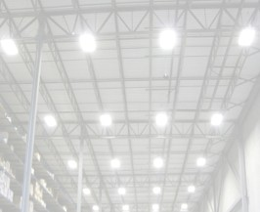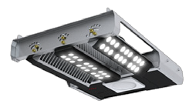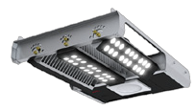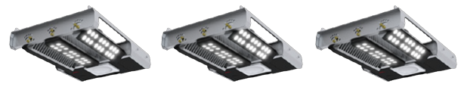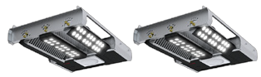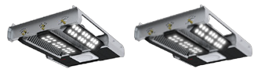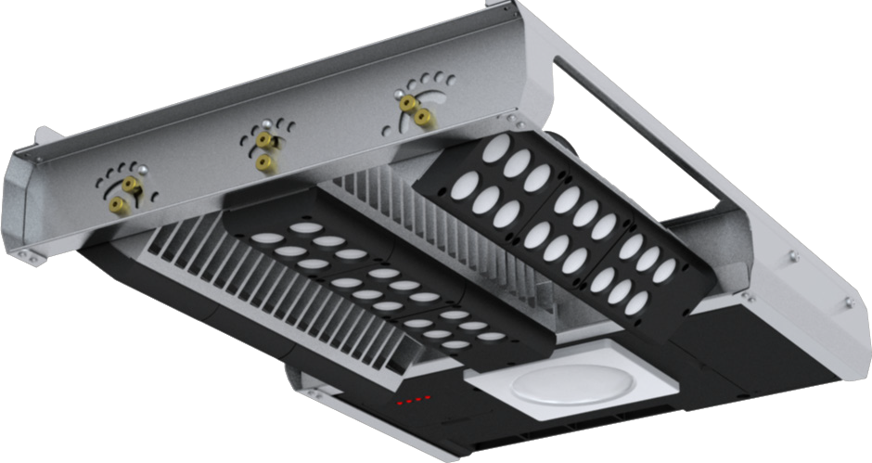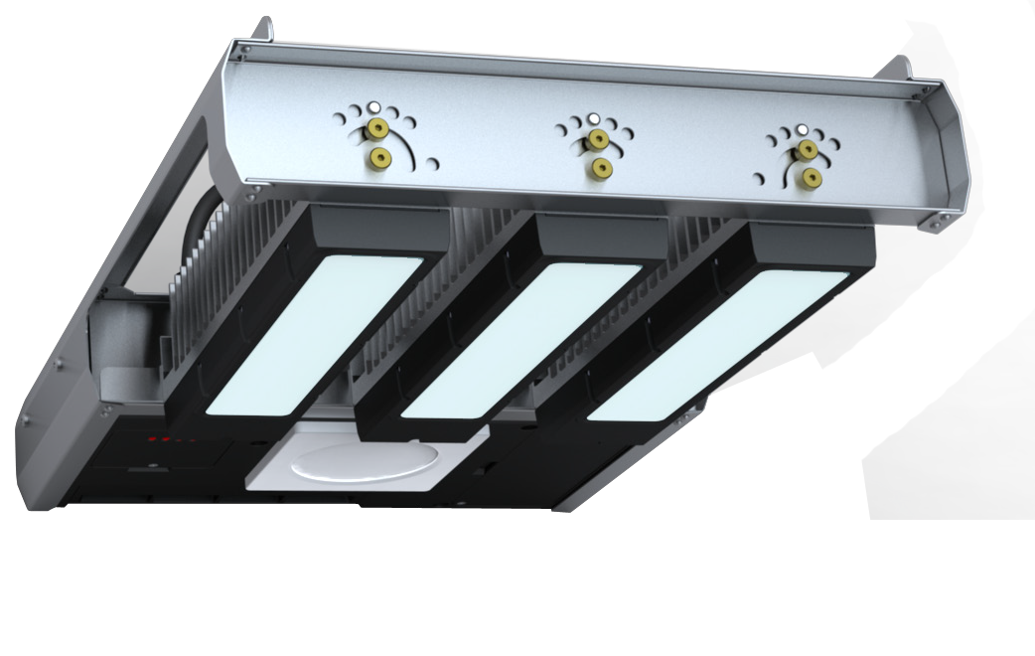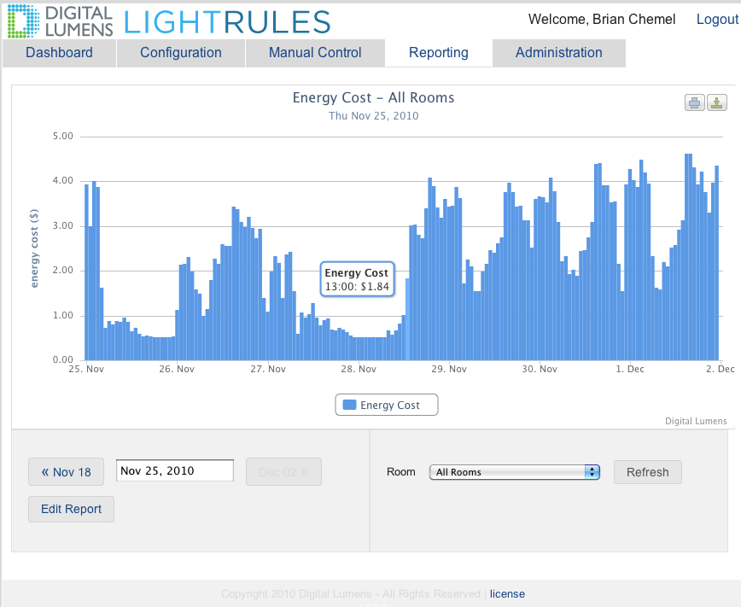

Smart Lights

Networked Wirelessly

Centrally Managed

Case Study

TOTAL COST OF OWNERSHIP COMPARISON

**HID HIF D ig i t al**

**Lu m e ns I L S**

System Type 400W MH 6L T5 ILE- HB -3

Lamp Life (Hrs) 20,000 30,000 50,000

Fixture Watts 465 293 160

Annual

Operating Hrs 8760 8760 1314 (15%)

Average

Electric Rate $0.10 $0.10 $0.10

Total Fixtures 100 100 10 0

Annual

Energy Expenses $40,734 $25,667 $2 ,102

Percent Energy

Savings 37% 95%

10 yr

Maint. Expenses $35,040 $21,608 $0

Digital Lumens ILS Traditional Lights

< 1 Year

Payback

10 yr TCO

$452,380

10 yr TCO

$114,024

Yr 1 Yr 2 Yr 3 Yr 4 Yr 5 Yr 6 Yr 7 Yr 8 Yr 9 Yr 10

About Digital Lumens

A pioneer in LED lighting, Digital Lumens is developing Intelligent Lighting Systems that dramatically reduce lighting energy use and improve light levels. The company, founded by LED industry veterans, is distinguished by breakthrough discoveries in technology, a management team of visionaries from the solid-state lighting and distributed networking industries, and proven results from real-world deployments.

[info@digitallumens.com](mailto:info@digitallumens.com)



110 Canal St, 7th Floor

Boston, MA USA 02114

+1 (617) 723-1200

All Rights Reserved © 2011

Digital Lumens Incorporated

Subject to change without notice.

DOC-000061-06 Rev B 03-12